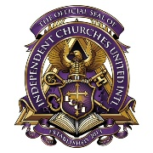 S.E.A.L. 2026 Class Schedule 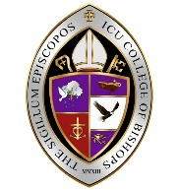
CLINICIANS AND CLINICS (Theme: Remnant Revival)
“God has never needed the majority-He has always moved through the remnant. The question is not how many we are, but how faithful we will be.”
Friday – July 17, 2026
Morning Prayer/ Devotional |  | 8:00 AM – 8:45 AM
Track I – Remnant Identity | Workshop | 9:00 AM – 9:50 AM
Track II – Remnant Leadership | Workshop | 9:00 AM – 9:50 AM
Track III – Remnant Church | Workshop | 9:00 AM – 9:50 AM
Track IV – Remnant Lifestyle | Workshop | 9:00 AM – 9:50 AM
Track V – Remnant Witness | Workshop | 9:00 AM – 9:50 AM
BREAK |  | 9:50 AM – 10:00 AM
Elective | “Crowned with Grace: The Calling and Care of a Pastor’s Wife” | 10:00 AM – 10:50 AM
Elective | “Leading While Supporting: Influence Without a Platform” | 10:00 AM - !0:50 AM
Elective | “When the Shepherd Needs Strength: Health and Wellness for Leaders” | 10:00 AM – 10:50 AM
Elective | “AI and the Church: Tool or Threat?” | 10:00 AM – 10:50 AM
Elective | “Maximizing What You Have: Worship in Small Churches” | 10:00 AM – 10:50 AM
BREAK |  | 10:50 AM – 11:00 AM
Elective | “Preaching for Transformation, Not Information” | 11:00 AM – 11:45 AM
Elective | “Spiritual Warfare and the Remnant Church” | 11:00 AM – 11:45 AM
Elective | “Ministering to the Grieving” | 11:00 AM – 11:45 AM
Elective | “Preaching for Transformation, Not Information” | 11:00 AM – 11:45 AM
Elective | “Developing Musicians in a Small Ministry Context” | 11:00 AM – 11:45 AM

